**PROJECT TEAM NO :-03**

**PROJECT TITLE :-**

**HOSPITAL MANGEMENT SYSTEM**



**PROJECT TEAM MEMBERS:**

**1.RAVI TEJA G (Team Lead)**

**EMP ID:-2478829,**

**EMAIL-ID:-ravi.g@mphasis.com**

**2.VANDANA DEVARINTI**

**EMP ID:-2478525,**

**EMAIL-ID:-devarinti.vandana@mphasis.com**

**3.SURYA.C**

**EMP ID:-2478359,**

**EMAIL-ID:-surya.c1@mphasis.com**

**4.SUMAN SANJEEB**

**EMP ID:-2478364,**

**EMAIL-ID:-suman.sanjeeb@mphasis.com**

**5.POTHURI SUMANTH**

**EMP ID:-2479145,**

**EMAIL-ID:-pothuri.sumanth@mphasis.com**

**6.DHINESH SHANMUGASUNDARAM**

**EMP ID:-2478469,**

**EMAIL-ID:-dhinesh.s@mphasis.com**

**7.LAKSHMI PRASANNA**

**EMP ID:-2479033,**

**EMAIL-ID:-kasetty.prasanna@mphasis.com**

**8.DASARI PRASAD**

**EMP ID:-2478754,**

**EMAIL-ID:-dasari.prasad@mphasis.com**

**9.VIRUPAKSHAPPA J SATANNAVARA**

**EMP ID:-2478341,**

**EMAIL-ID:-virupakshappa.s@mphasis.com**

**10.SHWETA SATPUTE**

**EMP ID:-2478369,**

**EMAIL-ID:-shweta.satpute@mphasis.com**

**TABLE OF CONTENTS:-**

1.INTRODUCTION **……………………………………**

2.SYSTEM OVERVIEW **………………………….........**

**3.** SUB-SYSTEM DETAILS **……………………………**

4.DATA ORGANIZATION **…………………………**

**5.**REST APIS TO BE BUILT **…………………………..**

**6.**ASSUMPTIONS **………………………………………**

**7.**ADVANTAGES **………………………………………**

**8.**OUTPUT SCREENSHOTS OF HMS **…………………**

# 

# INTRODUCTION

#### ABSTRACT

Hospital Management System is an organized computerized system designed and programmed to deal with day to day operations and management of the hospital activities. The program can look after inpatients, outpatients, status illness. It also maintains hospital information such as doctors and department administering. The major problem for the patient nowadays to get report after consultation , many hospital managing reports in their system but it's not available to the patient when he / she is outside. In this project we are going to provide the extra facility to store the report in the database and make available from anywhere in the world.

## INTRODUCTION:

The project Hospital Management system includes registration of patients, storing their details into the system. The software has the facility to give a unique id for every patient and stores the details of every patient and the staff automatically. User can search availability of a doctor and the details of a patient using the id. The Hospital Management System can be entered using a username and password. It is accessible either by an administrator. The data can be retrieved easily. The interface is very user-friendly. The data are well protected for personal use and makes the data processing very fast. Hospital Management System is powerful, flexible, and easy to use and is designed and developed to deliver real conceivable benefits to hospitals. Hospital Management System is designed for multispeciality hospitals, to cover a wide range of hospital administration and management processes. It is an integrated end-to end Hospital Management System that provides relevant information across the hospital to support effective decision making for patient care, hospital administration in a seamless flow.

Hospital Management System is a software product suite designed to improve the quality and management of hospital management in the areas of clinical process analysis and activity-based costing. Hospital Management System enables you to develop your organization and improve its effectiveness and quality of work. Managing the key processes efficiently is critical to the success of the hospital helps you manage your processes.

#### 1.2 Overview

#### Objective

* + 1. Define hospital
    2. Recording information about the Patients that come.
    3. Generating bills.
    4. Recording information related to diagnosis given to Patients.
    5. Keeping record of the Immunization provided to children/patients.
    6. Keeping information about various diseases and medicines available to cure them.

#### Scope of the Project:-

1. Information about Patients is done by just writing the Patients name, age and gender. Whenever the Patient comes up his information is stored freshly.
2. Bills are generated by recording price for each facility provided to Patient on a separate sheet and at last they all are summed up.
3. Diagnosis information to patients is generally recorded on the document, which contains Patient information. It is destroyed after some time period to decrease the paper load in the office.
4. Immunization records of children are maintained in pre-formatted sheets, which are kept in a file.
5. Information about various diseases is not kept as any document. Doctors themselves do this job by remembering various medicines.

All this work is done manually by the admin and other operational staff and lot of papers are needed to be handled and taken care of. Doctors have to remember various medicines available for diagnosis and sometimes miss better alternatives as they can’t remember them at that time.

### **MODULES:**

The entire project mainly consists of 3 modules, which are

* Admin module
* User module (patient)
* Doctor module

**1.3.1 Admin module:**

* manage department of hospitals, user, doctor.
* watch appointment of doctors
* Admin can be able to see the feedback which was given by the Patients.
* Admin can able to make changes in Doctors list.
* Admin can able to make changes in Patient list.

### **user module(patient):**

* View register appointment list and status with doctors
* Patient should fill the form when the Patient was discharged
* View doctor list

### **Doctor module:**

* Manage appointment with patient
* Doctor can able to see the discharged Patients list
* Doctor can be sign up

1. **. SYSTEM OVERVIEW**

#### List of Modules for Hospital Management System :

* + - **Patient Management:** This module covers from the process of intake until discharge of an account of the patient’s engagement with the health-care team. Communication, empathy, examination, evaluation, diagnosis are all part of the process.
    - **Doctor Management:** The management of the physicians would be included in creating this system. Through this process, the admin will have the information and transactions made by the doctors with the patients.
    - **Appointment Management:** This process is a tool that helps hospital admin manage their appointments. Internet booking is one of the tools available in an appointment management solution. Booking with a mobile app.

These modules must be present in creating the Hospital Management to satisfy the needs in managing Hospital transactions. Through this, the management and monitoring of patients would be much easier for both hospital admin and physicians.

#### REQUIREMENT SPECIFICATION

#### INTRODUCTION:

To be used efficiently, all computer software needs certain hardware components or the other software resources to be present on a computer. These pre-requisites are known as(computer) system requirements and are often used as a guideline as opposed to an absolute rule.

Most software defines two sets of system requirements: minimum and recommended. With increasing demand for higher processing power and resources in newer versions of software, system requirements tend to increase over time. Industry analysts suggest that this trend plays a biggerpart in driving upgrades to existing computer systems than technological advancements.

#### HARDWARE REQUIREMENTS:

The most common set of requirements defined by any operating system or software application is the physical computer resources, also known as hardware. A hardware requirements list is often accompanied by a hardware compatibility list (HCL), especially in case of operating systems. An HCL lists tested, compatibility and sometimes incompatible hardware devices for a particular operating system or application. The following sub-sections discuss the various aspects of hardware requirements.

#### HARDWARE REQUIREMENTS FOR PRESENT PROJECT:

PROCESSOR : DELL

RAM : 4 GB

HARD DISK : 80 GB

#### SOFTWARE REQUIREMENTS:

Software Requirements deal with defining software resource requirements and pre-requisites that need to be installed on a computer to provide optimal functioning of an application. These requirements or pre-requisites are generally not included in the software installation package and need to be installed separately before the software is installed.

#### SOFTWARE REQUIREMENTS FOR PRESENT PROJECT:

OPERATING SYSTEM : Windows 11

FRONT END : Html, css, Angular

BACKEND : Spring Boot

SERVER SIDE SCRIPT : Apache tomcat 8

DATABASE : Mysql

* 1. AUTHENTICATION AND AUTHORIZATION:

Authentication:

Every time we signed up, we likely been asked to create a username and password. Because this is such a common process now, it's become almost second-nature for some users to set up their accounts without much thought about the credentials they choose. And unfortunately, there's a lot at stake if a user chooses weak credentials.

Authentication for User name and password:

When a user first signs up for website, they're asked to choose a username and password to identify themselves. In an ideal world, the user would always pick a strong and unique password so that it's harder for an attacker to guess.

Password Rules:

When it comes to password safety, the longer and more complex the password is, the better. We think its good practice to enforce certain minimum requirements when asking users to create a new password. Of course, you have to find a balance between these requirements and user experience. If you make the sign-up process too tedious, you could be driving users away. To enforce password strength, you should define a set of rules that a password must satisfy and then enforce these with form validation.

Example password strength rules:

* + - Minimum of 8 characters
    - Maximum of 16 characters
    - Conform password and Main password should be same

2.3.1 Authorization:

For Authorization, think of owning a hospital page. When admin log in, since he own the page. Hence, admin can post content on page, modify and even approve content from doctors and patient and others of your page that are not administrators. When users who are not administrators try to approve other people's content, they'll find out they can't. This is because they don't have the right to do that; only admins can.

* 1. **E-R DIAGRAMS**

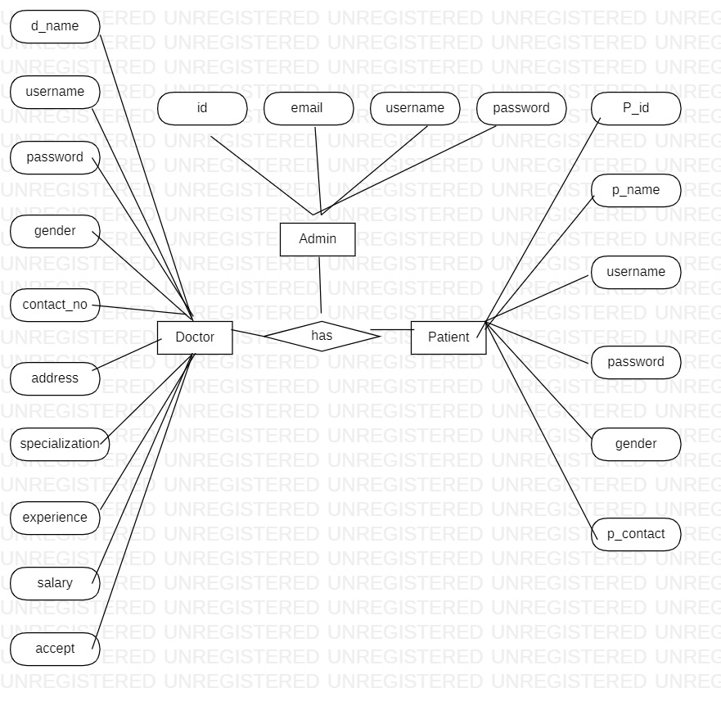

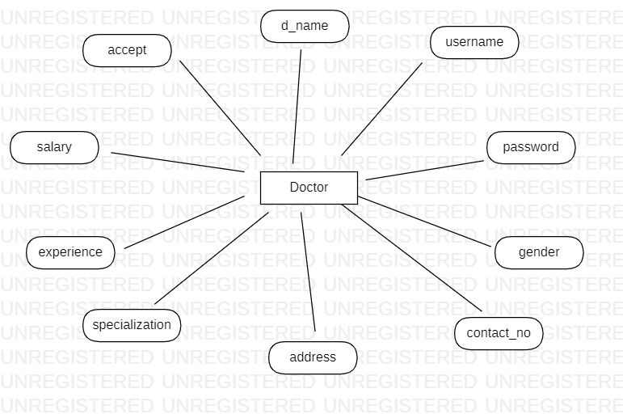

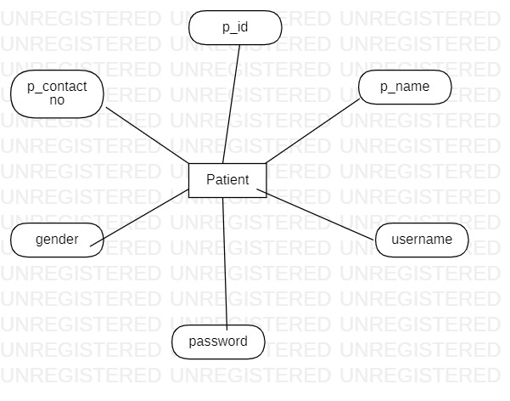

### 

Patient signup table:

|  |  |  |  |
| --- | --- | --- | --- |
| **Column** | **Data Type** | **Length** | **Nulls** |
| **User name** | **varchar** | 255 | no |
| **Password** | **varchar** | **255** | yes |
| **P-id** | **Int** |  |  |
| **P-Contact No** | **varchar** | **255** | yes |
| **P -gendr** | **varchar** | **255** | yes |
| **P-Name** | **varchar** | **255** | yes |

Doctor signup table:

|  |  |  |  |
| --- | --- | --- | --- |
| **Column Name** | **Data Type** | **Length** | **Nulls** |
| **d_ID** | **Int** |  | **-** |
| **Accept** | **Varchar** | **255** | **Yes** |
| **Address** | **Varchar** | **255** | **Yes** |
| **Contact-no** | **Varchar** | **255** | **Yes** |
| **d-name** | **Varchar** | **255** | **Yes** |
| **Experiance** | **Varchar** | **255** | Yes |
| **gender** | **Varchar** | **255** | Yes |
| **Password** | **varchar** | **255** | Yes |
| **Salary** | **varchar** | **255** | Yes |
| **Specialization** | **varchar** | **255** | Yes |

Patient login:

|  |  |  |  |
| --- | --- | --- | --- |
| **Column Name** | **Data Type** | **Length** | **Nulls** |
| **username** | **Varchar** | **255** | **-** |
| **password** | **Varchar** | **255** | **-** |

Doctor login:

|  |  |  |  |
| --- | --- | --- | --- |
| **Column Name** | **Data Type** | **Length** | **Nulls** |
| **username** | **Varchar** | **255** | **-** |
| **password** | **Varchar** | **255** | **-** |

Admin login:

|  |  |  |  |
| --- | --- | --- | --- |
| **Column Name** | **Data Type** | **Length** | **Nulls** |
| **username** | **Varchar** | **255** | **-** |
| **password** | **Varchar** | **255** | **-** |

Appointment Table:

|  |  |  |  |
| --- | --- | --- | --- |
| **Column Name** | **Data Type** | **Length** | **Null** |
| **Ap-id** | **Number** |  |  |
| **Address** | **Varchar** | **255** | Yes |
| **Ap-date** | **Varchar** | **255** | Yes |
| **Ap-time** | **Varchar** | **255** | Yes |
| **D-name** | **Varchar** | **255** | Yes |
| **disease** | **Varchar** | **255** | Yes |
| **gender** | **Varchar** | **255** | Yes |
| **p-name** | **Varchar** | **255** | yes |

Feedback table:

|  |  |  |  |
| --- | --- | --- | --- |
| **Column Name** | **Data Type** | **Length** | **Nulls** |
| **Feedback_id** | **Int** |  |  |
| **P_comments** | **Varchar** | **255** | Yes |
| **P-id** | **Int** |  | Yes |

# 3. Sub-System Details

The Hospital Management System is defined, where in all users need to login successfully before performing any of their respective operations. Below tables that provides functionality descriptions for each type of user . Against each requirement, indicative data is listed in column ‘Data to include’.

* 1. Admin

###### The admin as a user is defined to perform below listed operations after once admin login.

|  |  |  |  |
| --- | --- | --- | --- |
| **Objects** | **Operations** | **Data to include** | **Remarks** |
| User | register | Admin id,admin name, contact  no,username,password |  |
| Doctor list | view | Doctor id, doctor name |  |
| Appointments | Approve/reject | Appointment id, address, date, status, time, doctor id, patient id |  |
| Patients List | view | Patient id, patient name |  |

## Doctor

###### The doctor as a user is defined to perform below listed operations after once doctor login.

|  |  |  |  |
| --- | --- | --- | --- |
| **Objects** | **Operations** | **Data to include** | **Remarks** |
| **User** | Register | Doctor id, doctor name,  username, password, gender, mail id, specialization |  |
| **Patients Lists** | View | Patient id, patient name |  |
| **Appointments** | View | Patient id, disease, appointment time |  |
| **Discharge Patients** |  | Patient id, patient name |  |

## Patient

## The Patient as a user is defined to perform below listed operations after once Patient login.

|  |  |  |  |
| --- | --- | --- | --- |
| **Objects** | **Operations** | **Data to include** | **Remarks** |
| User | Register | Patient id, dob,contactno,gender,patient name, password |  |
| Appointment | Register | Appointment id, address, date, status, time, doctor id, patient id |  |

# 

# 4 Data Organization

###### This section explains the data storage requirements of the Product Order Entry System and indicative data description along with suggested table (database) structure. The following section explains few of the tables (fields) with description. However, in similar approach need to be considered for all other tables.

###### **Admin Registration table**

|  |  |
| --- | --- |
| **Field Name** | **Description** |
| Admin_id | Admin id is auto generated after registration and it is used as Login ID. |
| Admin_name | Name of the admin |
| Username | Name of the admin |
| Password | User unique password |

###### **Patient Registration table**

|  |  |
| --- | --- |
| **Field Name** | **Description** |
| Patient_id | Patient id is auto generated after registration and it is used as Login ID. |
| Patient_name | Name of the Patient |
| Patient_gender | Give gender weather Male\Female |
| Username | Name of the Patient |
| Password | User unique password |
| Patient contact number | 1. igits patient mobile number |

###### **4.3 Doctor Registration table**

|  |  |
| --- | --- |
| **Field Name** | **Description** |
| Doctor_id | Doctor id is auto generated after registration and it is used as Login ID. |
| Doctor_name | Name of the doctor |
| Contact_no | 10 digits mobile number |
| Username | Name of the Doctor |
| Password | User unique password |
| Gender | Mention whether doctor male\female |
| Specialization | Doctor Specialization or expert |

###### **Appointment table**

|  |  |
| --- | --- |
| **Field Name** | **Description** |
| Appointment_id | Appointment id is auto generated after appointment filled successfully. |
| Patient_id | Id of patient |
| Doctor_id | Id of the doctor to whom you were referred |
| Address | Complete Address of the Patient |
| Appointment time | At what time the patient want to schedule the appointment |

###### **4.5.Feedback table**

|  |  |
| --- | --- |
| **Field Name** | **Description** |
| Patient_id | Id of patient |
| Comments | Feedback to be given In 50 words |

###### **4.6.Discharge Table**

|  |  |
| --- | --- |
| **Field Name** | **Description** |
| Appointment_id | Appointment id which was given |
| Patient_id | Id of patient |
| Discharge_date | The date of discharge |
| Disease | Patient Disease |
| Amount paid | Clearance of bill amount |

# 

# 5 REST APIS TO BE BUILT.

###### Create following REST resources which are required in the application,

###### 1. Creating Admin Entity: Create Spring Boot with Microservices Application with Spring Data JPA

###### Technology stack:

###### Spring Boot

###### Spring REST

###### Spring Data JPA

###### Here will have multiple layers into the application:

###### Create an Entity: Admin

###### Create a AdminRepository interface and will make use of Spring Data JPA

###### Will have findByAdminme method.

###### Add the Admin details

###### Create a Admin Service class and will expose all these services.

###### Finally, create a AdminRestController will have the following Uri’s:

http://localhost:8081/adminlogin

http://localhost:8081/registerAdmin

http://localhost:8081/api/v1/appointments

http://localhost:8081/api/v1/dischargedpatients <http://localhost:8081/api/v1/feedbac>

http://localhost:8081/api/v1/doctors

http://localhost:8081/api/v1/doctorlogin

http://localhost:8081/api/v1/feedbacks

http://localhost:8081/api/v1/patientlogin

http://localhost:8081/api/v1/patients

http://localhost:8081/api/v1/patient

http://localhost:8081/registerAdmin

# 

# 6.Assumptions

* Each user(Admin,doctor,patient) must have a valid user id and password
* Server must be running for the system to function
* Users must log in to the system to access any record.
* Only the Administrator can delete records.

###### Only admin can approve appointment, discharge, generate invoice.

**7.ADVANTAGES:**

* 1. Digital Medical Records
  2. Less time consuming
  3. Insurance claim functions
  4. Patient self-service
  5. Financial control and taxpaying
  6. Staff interactions

Digital medical records :

The hospital database includes all the necessary patient data. The disease history, test results, prescribed treatment can be accessed by doctors without much delay in order to make an accurate diagnosis and monitor the patient’s health. It enables lower risks of mistakes.

Less time consuming:

As the services and interactions are improved in all possible ways, everything is being planned with greater precision. It saves the time of all the system users and provides them with up-to-date information.

Insurance claims processing:

Integration with health insurance services improves the experience of the patients and brings benefits to the institution. It allows you to be innovative and helps both the patient and hospital to handle many aspects of the insurance process successfully.

Patient self-service:

Patients have their own system accounts where the list of various actions can be performed. They are able to make online requests or reservation, receive the test results, receive the consultation of the medical specialists and many more.

Financial control and tax planning:

###### The management has the ability to monitor different financial operations including expenses, profits, and losses, paying bills and taxes, in and outpatient billing. The financial awareness helps to analyze business prospects quite clear and move in the right direction

# 8. OUTPUT SCREENSHOTS OF HMS

# C:\Users\chand\Downloads\WhatsApp Image 2022-03-06 at 5.07.56 PM (1).jpeg

# C:\Users\chand\Downloads\WhatsApp Image 2022-03-06 at 5.07.57 PM.jpeg

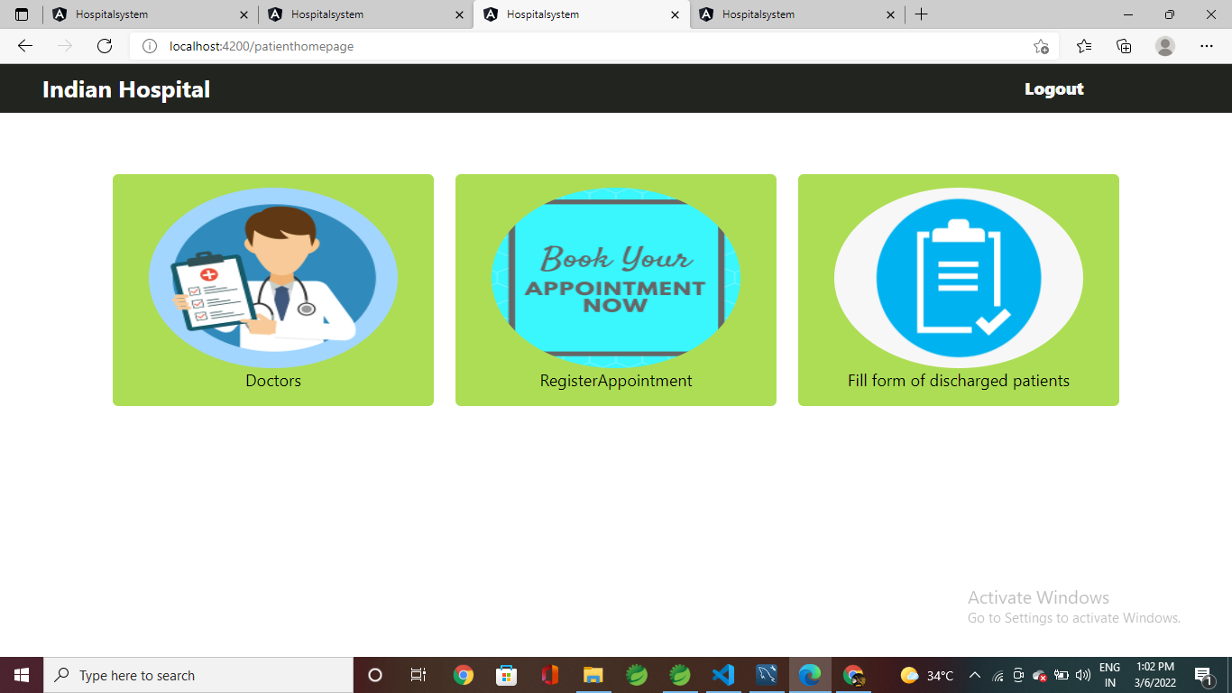

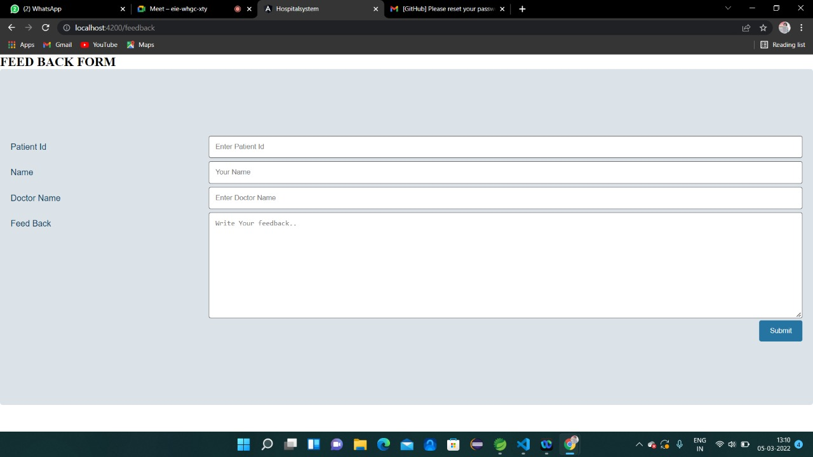

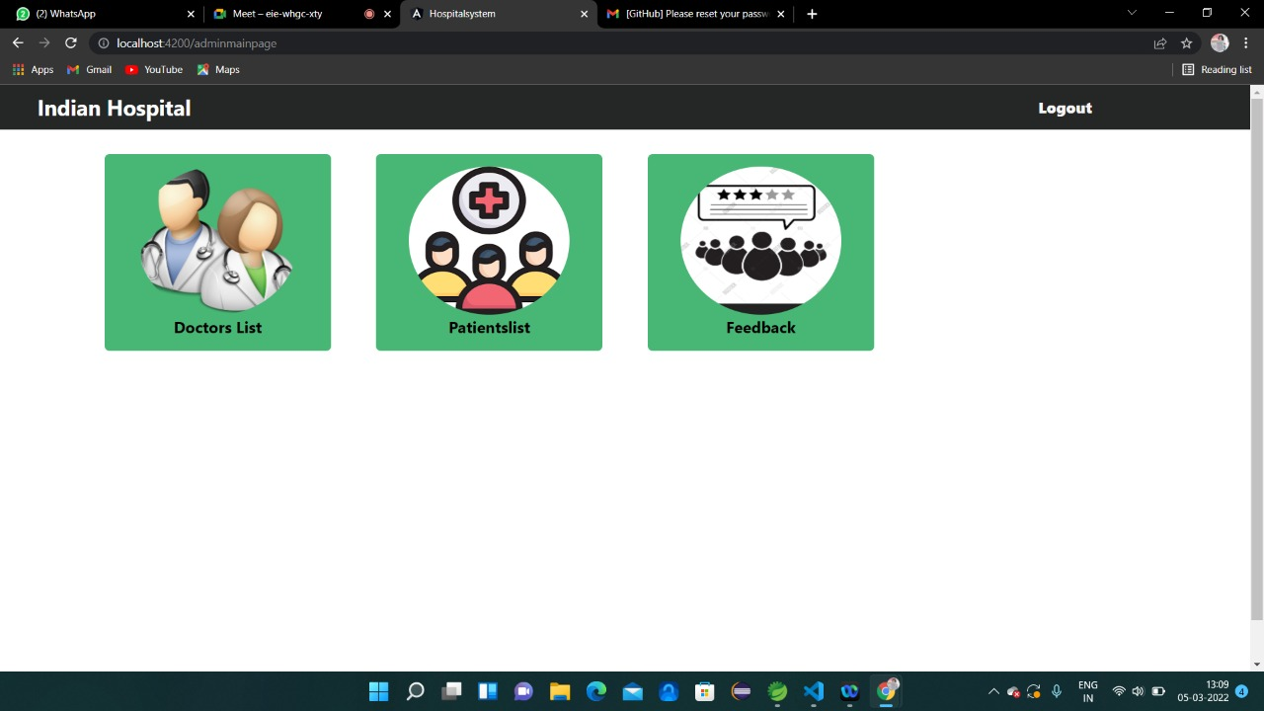

**CONCLUSION:**

Hospital management systems allows us the ability to optimize and digitize all the processes within the institution, which will help to improve customer service, reduce process costs, streamline the search of medical records, bills, patients, doctors, etc.; thus, having a database of each module implemented. HMS will contributed enormously to better health and influenced the lives and well-being of billions of humans.